**Documentation HR-Management**

The HR Management system is a comprehensive software application designed to automate the human resource management process of an organization. It provides a centralized platform for managing various HR functions, including employee information, attendance tracking, performance management, and payroll processing. The system is designed to help HR professionals streamline their workflow, improve data accuracy, and reduce manual effort.

The HR Management system manages several key entities, including employees, departments, designations, attendance, awards, appreciation, deductions, events, expense-reclaims, leave applications, leave types, leave policies, employee salaries, overtimes, taxes, teams, time sheets. These entities are critical to the HR function of an organization and are essential for effective management of the workforce.

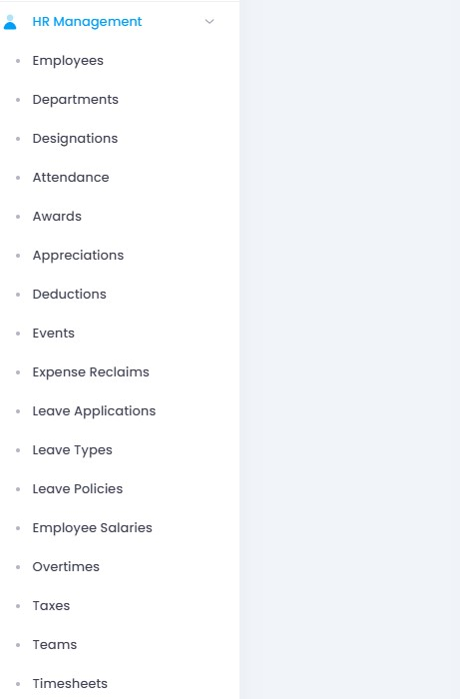

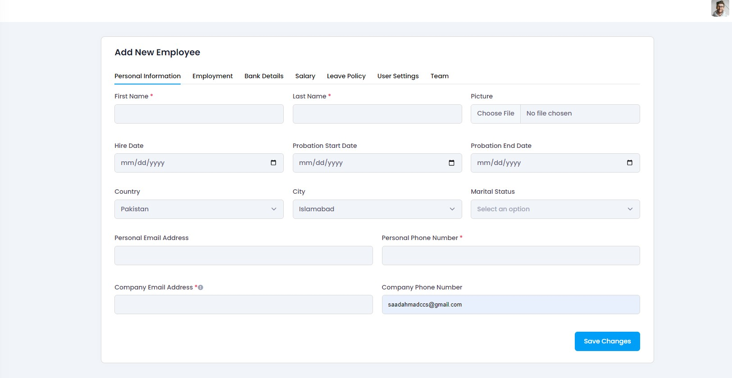

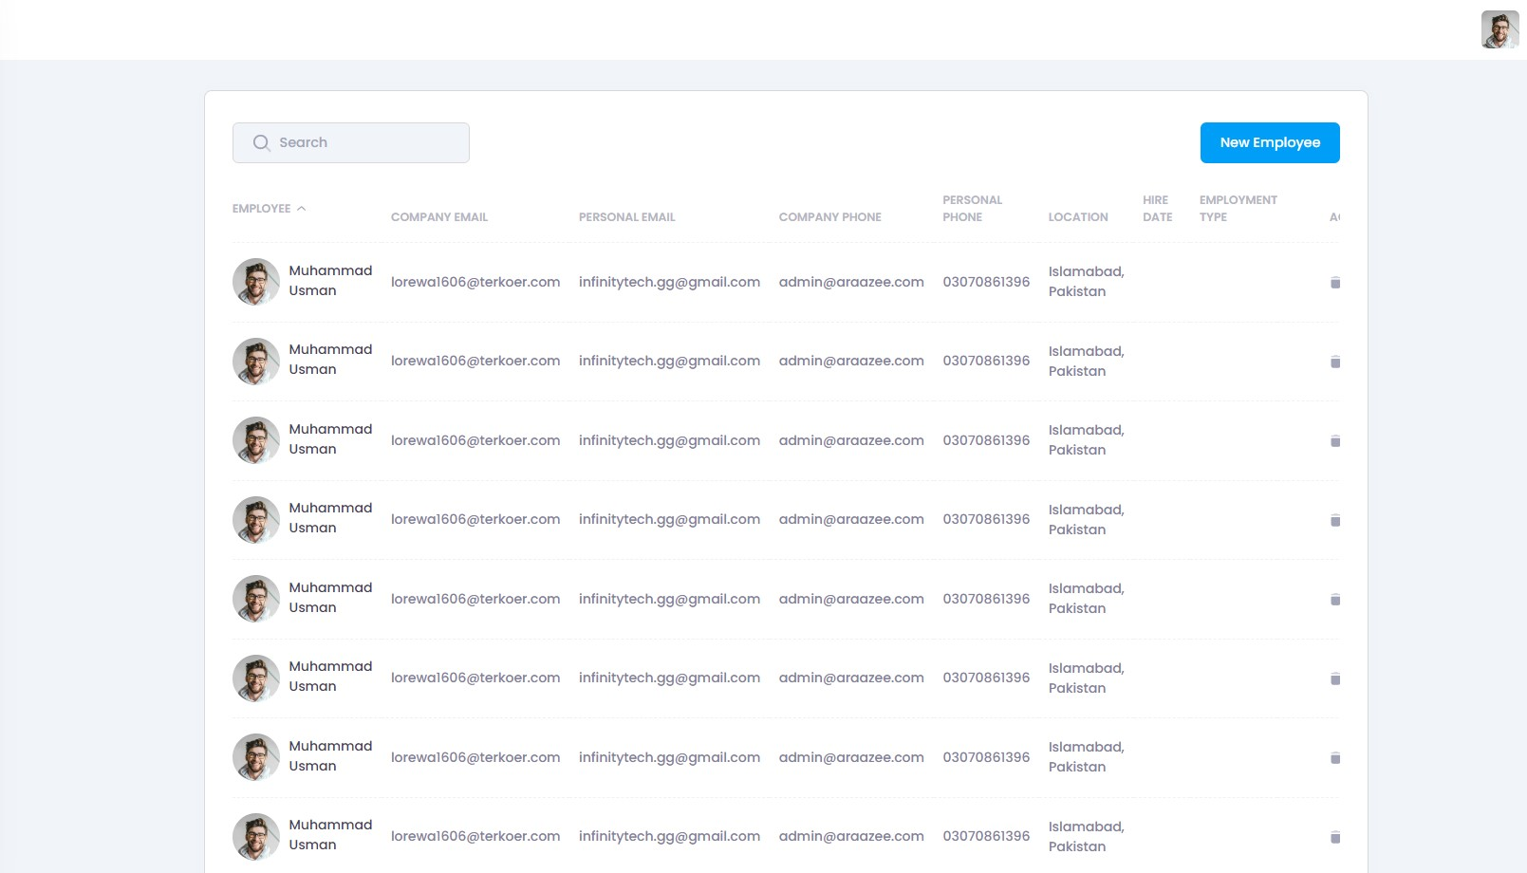

**1. Employee Management**Introduction:

This document provide an overview of the employee management module in the HR-Management system.

Who Can Use it:

This document is intended for developers, system administrators, and end-users who will interact with the employee management module.

Functionalities and Cases:

1. Employee Record View

In this view the admin or operator of the software will be able to see the record of the employee like his name, email and other credentials.

1. Add New Employee

In the employee view page you will also find the option of add new employee at the top. In the add new employee you can add a new employee to the system.

1. Update Employee

In view Employee you can also find an option to update the employee information and data.

1. Delete Employee

In the view employee there is an option to delete the employee record if it is not of use

**2. Department Management**Introduction:

This part provide an overview of the department management module in the HR-Management system.

Who Can Use it:

This document is intended for developers, system administrators, and end-users who will interact with the department management module.

Functionalities and Cases:

1. Departments Record View

In this view the admin or operator of the software will be able to see the record of the department like name and other information.

1. Add New Department

In the department view page you will also find the option of add new department at the top. In the add new department you can add a new department to the system.

1. Update Department

In view department you can also find an option to update the department information and data.

1. Delete Department

In the view department there is an option to delete the employee record if it is not of use

**3. Designations Management**Introduction:

This document provide an overview of the designation management module of employee in the HR-Management system.

Who Can Use it:

This document is intended for developers, system administrators, and end-users who will interact with the designation management module.

Functionalities and Cases:

1. Designations Record View

In this view the admin or operator of the software will be able to see the record of the employee designation like role and other information.

1. Add New Designation

In the designation view page you will also find the option of add new designation at the top. In the add new designation you can add a new designation to the system.

1. Update Employee

In view Designation you can also find an option to update the designation information and data.

1. Delete Employee

In the view designation there is an option to delete the designation record if it is not of use

**4. Attendance Management**Introduction:

This document provide an overview of the Attendance management module in the HR-Management system.

Who Can Use it:

This document is intended for developers, system administrators, and end-users who will interact with the Attendance management module.

Functionalities and Cases:

1. Attendance Record View

In this view the admin or operator of the software will be able to see the record of the Attendance of the employee.

1. Add New Attendance

In the Attendance view page you will also find the option of mark attendance at the top. In the mark new Attendance you can mark a new Attendance of employee to the system.

**5. Awards Management**Introduction:

This document provide an overview of the Awards management module of employee in the HR-Management system.

Who Can Use it:

This document is intended for developers, system administrators, and end-users who will interact with the Awards management module.

Functionalities and Cases:

1. Awards Record View

In this view the admin or operator of the software will be able to see the record of the Awards like his name, email and other credentials.

1. Add New Awards

In the Awards view page you will also find the option of add new Awards at the top. In the add new awards you can add a new awards type to the system.

1. Update Awards

In view Awards you can also find an option to update the Awards information and data.

1. Delete Awards

In the view Awards there is an option to delete the Awards record if it is not of use

**6. Appreciations Management**Introduction:

This document provide an overview of the Appreciations management module in the HR-Management system.

Who Can Use it:

This document is intended for developers, system administrators, and end-users who will interact with the Appreciations management module.

Functionalities and Cases:

1. Appreciations Record View

In this view the admin or operator of the software will be able to see the record of the Appreciations like name of employee and other credentials.

1. Add New Appreciations

In the Appreciations view page you will also find the option of add new Appreciations at the top. In the add new Appreciations you can give an appreciation to the employee and add it to the system.

1. Update Appreciations

In view Appreciations you can also find an option to update the Appreciations information and data.

1. Delete Appreciations

In the view Appreciations there is an option to delete the Appreciations record if it is not of use.

**7. Deductions Management**Introduction:

This document provide an overview of the Deductions management module in the HR-Management system.

Who Can Use it:

This document is intended for developers, system administrators, and end-users who will interact with the Deductions management module.

Functionalities and Cases:

1. Deductions Record View

In this view the admin or operator of the software will be able to see the record of the Deductions like employee name, date, amount and other information.

1. Add New Deductions

In the Deductions view page you will also find the option of add new Deductions at the top. In the add new Deductions you can add a new Deductions record to the system.

**8. Events Management**Introduction:

This document provide an overview of the events management module in the HR-Management system.

Who Can Use it:

This document is intended for developers, system administrators, and end-users who will interact with the events management module.

Functionalities and Cases:

1. Events Record View

In this view the admin or operator of the software will be able to see the record of the events like venue, start-end-date and other information.

1. Add New Events

In the events view page you will also find the option of add new events at the top. In the add new events you can add a new event record to the system.

1. Update Events

In view Events you can also find an option to update the events information and data.

1. Delete Events

In the view events there is an option to delete the events record if it is not of use

**9. Expense Reclaims Management**Introduction:

This document provide an overview of the expense reclaims management module in the HR-Management system.

Who Can Use it:

This document is intended for developers, system administrators, and end-users who will interact with the expense reclaims management module.

Functionalities and Cases:

1. Expense reclaims Record View

In this view the admin or operator of the software will be able to see the record of the expense reclaims like employee name, currency, category and other information.

1. Add New Expense reclaims

In the expense reclaims view page you will also find the option of add new expense reclaims at the top. In the add new expense reclaims you can add a new expense reclaims to the system.

1. Update Expense reclaims

In view Expense reclaims you can also find an option to update the expense reclaims information and data.

1. Delete Expense reclaims

In the view expense reclaims there is an option to delete the expense reclaims record if it is not of use

**10. Leave applications Management**Introduction:

This document provide an overview of the leave applications management module in the HR-Management system.

Who Can Use it:

This document is intended for developers, system administrators, and end-users who will interact with the leave applications management module.

Functionalities and Cases:

1. Leave applications Record View

In this view the admin or operator of the software will be able to see the record of the leave applications like duration, start-end-date and other information.

1. Add New Expense reclaims

In the Leave applications view page you will also find the option of add new leave applications at the top. In the add new leave applications you can add a new leave applications to the system.

1. Update Expense reclaims

In view Leave applications you can also find an option to update the leave applications information and data.

1. Delete Expense reclaims

In the view leave applications there is an option to delete the leave applications record if it is not of use

**11. Leave Types Management**Introduction:

This document provide an overview of the leave type management module in the HR-Management system.

Who Can Use it:

This document is intended for developers, system administrators, and end-users who will interact with the leave type management module.

Functionalities and Cases:

1. Leave Types Record View

In this view the admin or operator of the software will be able to see the record of the leave type like name, color and other information.

1. Add New Leave Types

In the leave type view page you will also find the option of add new leave type at the top. In the add new leave type you can add a new leave type to the system.

1. Update Leave Types

In view Leave type you can also find an option to update the leave types.

1. Delete Leave Types

In the view leave type there is an option to delete the leave type record if it is not of use

**12. Leave Policies Management**Introduction:

This document provide an overview of the leave policies management module in the HR-Management system.

Who Can Use it:

This document is intended for developers, system administrators, and end-users who will interact with the leave policies management module.

Functionalities and Cases:

1. Leave Policies Record View

In this view the admin or operator of the software will be able to see the record of the leave policies like name, description and other information.

1. Add New Leave Policies Record

In the leave policies view page you will also find the option of add new leave policies at the top. In the add new leave policies you can add a new leave policies to the system.

1. Update Leave Policies Record

In view Leave policies you can also find an option to update the leave policies information and data.

1. Delete Leave Policies Record

In the view leave policies there is an option to delete the leave policies record if it is not of use

**13. Employee Salaries Management**Introduction:

This document provide an overview of the Employee Salaries management module in the HR-Management system.

Who Can Use it:

This document is intended for developers, system administrators, and end-users who will interact with the Employee Salaries management module.

Functionalities and Cases:

1. Employee Salaries Record View

In this view the admin or operator of the software will be able to see the record of the Employee Salaries cycle, taxable and other information.

1. Add New Employee Salaries

In the Employee Salaries view page you will also find the option of add new Employee Salaries at the top. In the add new Employee Salaries you can add a new Employee Salaries to the system.

**14. Overtimes Management**Introduction:

This document provide an overview of the Overtimes management module in the HR-Management system.

Who Can Use it:

This document is intended for developers, system administrators, and end-users who will interact with the Overtimes management module.

Functionalities and Cases:

1. Overtimes Record View

In this view the admin or operator of the software will be able to see the record of the Overtimes like title, timesheet and other information.

1. Add New Expense reclaims

In the Overtimes view page you will also find the option of add new Overtimes at the top. In the add new Overtimes you can add a new Overtimes to the system.

1. Update Expense reclaims

In view Overtimes you can also find an option to update the Overtimes information and data.

1. Delete Expense reclaims

In the view Overtimes there is an option to delete the Overtimes record if it is not of use

**15.Taxes Management**Introduction:

This document provide an overview of the Tax management module in the HR-Management system.

Who Can Use it:

This document is intended for developers, system administrators, and end-users who will interact with the Tax management module.

Functionalities and Cases:

1. Taxes Record View

In this view the admin or operator of the software will be able to see the record of the taxes like tax name, percentage amount and other information.

1. Add New Tax Data

In the Taxes view page you will also find the option of add new Taxes at the top. In the add new Taxes you can add a new Taxes to the system.

1. Update Taxes Data

In view Taxes you can also find an option to update the Taxes information and data.

1. Delete Tax Record

In the view Taxes there is an option to delete the Taxes record if it is not of use

**16. Teams Management**Introduction:

This document provide an overview of the Teams management module in the HR-Management system.

Who Can Use it:

This document is intended for developers, system administrators, and end-users who will interact with the Teams management module.

Functionalities and Cases:

1. Teams Record View

In this view the admin or operator of the software will be able to see the record of the Teams like name, department and other information.

1. Add New Team

In the Teams view page you will also find the option of add new Teams at the top. In the add new Teams you can add a new Teams to the system.

1. Update Team Record

In view Team page you can also find an option to update the Teams information and data.

1. Delete Team Record

In the view Teams page there is an option to delete the Teams record if it is not of use

1. View Team Members

In the view Teams page there is an option to view the Team members

**17. Time Sheets Management**Introduction:

This document provide an overview of the Time Sheets management module in the HR-Management system.

Who Can Use it:

This document is intended for developers, system administrators, and end-users who will interact with the Time Sheets management module.

Functionalities and Cases:

1. Time Sheets Record View

In this view the admin or operator of the software will be able to see the record of the Time Sheets like employee name, hours worked and other information.

1. Add Time Sheet

In the Time Sheets view page you will also find the option of add new Time Sheets at the top. In the add new Time Sheets you can add a new Time Sheets to the system.

1. Update Time Sheet

In view Time Sheets you can also find an option to update the Time Sheets information and data.

1. Delete Time Sheet

In the view Time Sheets there is an option to delete the Time Sheets record if it is not of use